In Workday, you can view grades at any time during the academic period. There are two kinds of grades - interim grades, and final grades.
Interim grades are updated as students move through the current academic period. Interim grades are helpful for assessing progress. Final grades are assigned at the end of academic period and are recorded in the students’ academic record.

Use this reference to assign interim grades.

INSTRUCTIONS – Assign interim grade
- Log into Workday and enter the Teaching app.

- Click “Assign Interim Grades”.

- The Assign Student Interim Grade for Student Course Section window will open. Click the Student Course Section field.

- Click My Assigned Course Sections to reveal a series of options. Note: Avoid the By Course Section option. It will display unfiltered, redundant information.

- Click the appropriate academic period. Click the appropriate course section. Click “OK”.

- A new page will open with the assigned students. Identify the student for which you want to assign the interim grade.

Locate and click the plus sign  corresponding to the student.

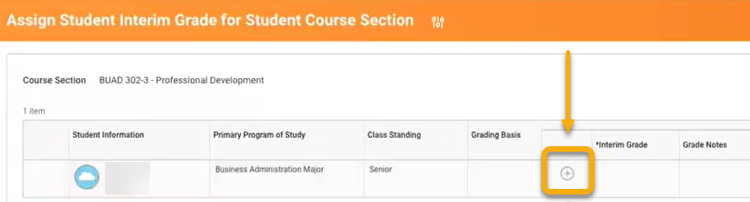

- In the Interim Grade column, a blank field will appear. Click the field and select a grade.

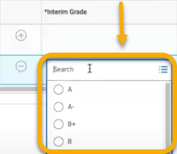

- When a grade is selected, a blank field will appear in the Grade Notes column. Enter any notes, if desired.

- Click “OK”.



- Proceed to the next student and follow the same steps. When complete, click “Done”.

